REG.NO.49/BHARAT/REG/2000-2001 ESTABLISHED:29 JUNE, 2000

MAA MADHURI BRIJ VARIS SEWA SADAN

^^lsok gh thou gS**

SANSTHA BAJHERA, BHARATPUR (RAJ.)

ANNUAL REPORT

YEAR 2013-14

Website: www.apnagharbharatpur.org
E-mail ID: mmbvss@gmail.com
Mob: 9950737673, 9414023049, 8764396811

PART A – PROGRESS REPORT
PART B – AUDIT REPORT
PART A- PROGRESS REPORT

ANNUAL REPORT-2013-2014

FORWARD

We are dedicated for achieving our mission ‘to serve the living statue of god.’ who is hopeless and facing painful phase of life. MMBVSS is putting all efforts to save the life of these persons with blessing of almighty god. They generally found at nearby railway station, religious and public places in very unhygienic situation suffered with critical diseases and painful conditions are seeking for amenities like food, cloth and medicine. Indeed they are unable to get even a glass of water. With this difficult situation the organization is fortunate to access them facilities to a large number of such persons who usually missing or die every year due to lack of required necessities. These are precious human resource and they should not loose their lives in absence of such requirements of life.
Increasing numbers of such helpless is showing declining of humanitarian and ethical code in family as well as in society where many individuals are often driven out from families or they forced to leave home. The Organisation make all efforts to save the life of these persons and give them an opportunity to live with respect and dignity.
Apna Ghar Units in the state in this year has played a significant role by evolving a new humanitarian concept through alliance and peoples based mechanism in order to addressing the problems of helpless, homeless and support less sick.
In mobilization of resources the community and philanthropy have done best efforts for inmates of Apna Ghar in this year. With the help of Apna Ghar Sewa Samities and Helplines members the scale and coverage has been expanded in other part of the state so that destitute person’s lives can be saved.
Visiting Apna Ghar gives pleasures to people visiting for peace and we wish all the visitors to strengthen the humanitarian value by helping inmates.
Community as our important stakeholders without whose contribution changes in the life of helpless is impossible. We further looking the same cooperation to every individual.

Secretary

EXPANSION OF INFRASTRUCTURE AND ACCOMODATION FACILITIES-

With passage of time and on basis of larger scale demand of Apna Ghar units in the state organization is seeking irrespectively a need of expansion of infrastructures and accommodation facilities to homeless, helpless and support less sick persons. Within them mostly they are suffering of mentality retarded, mentally sick, old aged, paralysis and infected persons. While expanding the accommodation and facilities, every inmate cases are taken into consideration. The expansion of infrastructures and accommodation facilities created during the year are as follows-

Apna Ghar Bansi Praklp:-
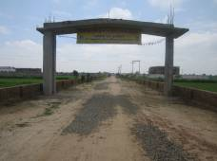
Looking to the accommodation necessity for next 10 years to the inmates as per the present rate of increase of inmates admitted in `Apna Ghar` construction of new `Apna Ghar ` having accommodation capacity for 2000 inmates had been started on dated 4 November 2011 at a distance of 2 km from the present building of `Apna Ghar` Ashram. This project is known as `Bansi Praklap`. For this project 10 acre of land was purchased by the Organisation during 2011-12 and the construction work of Phase-I has been completed and was inaugurated as on 23 March 2014 in presence of Spiritual Sant Sh Vijay Kaushal Ji Maharaj. At the time of inauguration 600 female inmates admitted in this block from the old Ashram. The main features of Phase-Ist Construction are as under.
BANSI PRAKALP ENTRANCE

- Matra Sadan (A Residential Home for Female):-
The ‘Matra Sadan’ is a Residential Home for
the Female having bedding capacity for 720 Inmates. In this Home a ‘Beauty Parlor’ for personal care , ‘Mandir and worship place for Other Religions for worship, Medical Section and Dispensary for proper treatment, music system, T.V. ,Video and Game for Recreation, Dining Hall for meal, laundry for washing cloths has been facilitated. In spite of this the electrification and proper water facility has been developed. In the Residential Ashram the other facility like bedding, clothing, washing, medical, disability equipments has also been arranged. The residential arrangement has been classified according to nature, age, disease, Physical and mental status in this Home. Total covered area of this home is 65000 sq feet.
BANSI PRAKALP RESIDENTIAL FOR FEMALE

- Ma Annpurna Prasadalay (Kitchen):-

his Kitchen has been developed
forpreparation of food for 3000 persons at a
time and classified as per need of Inmates
in four sections for preparing food according
to need of inmates. Quality and economy is the
main focus in this kitchen. Steam cooking system
has been installed which save about 50 % of cost
of cooking as compared to LPG gas and also the
BANSI PRAKALP KITCHEN
preparation is highly hygienic. One fully
automatic chapatti Machine having capacity 1000 chapatti per hour and other one semi automatic Machine having capacity 600 chapatti per hour has also installed in this kitchen which save not only the consumption of Gas but also the man power to be utilized for cooking. Other required equipments like refrigerator, machine for preparation of flour, D-freeze, grinder and mixture, service trolly, cookers, machine for potato peeling, utensils etc has also been arranged for the kitchen. The total constructed covered area of this kitchen is 5500 sq feet.
- Office & Store Building:-

For providing better administrational
services a Office having covered area of 16000 sq feet with basement, ground and first floor has been constructed and developed. The basement of the building is used for Main Store of the Ashram and conference hall and the ground is used for Administration having reception, waiting, computer, Accounts and cash section separately. This block also provide space for record room, office in charge and administrator including Executive Board of the Organisation. This Office block has been separated in three parts as Local Ashram Administration, State and National level
OFFICE & STORE BUILDING
Administration. The first floor of the building is used for Volunteers and guests. All required office furniture and equipments e.g. computers, tables, chairs, Almirah, racks, stationary, water cooler, freeze proper electrification and water fitting etc. has been settled and installed as per need.
- Staff Quarters & Garage:-
The staff quarters having residential capacity for 20 Employees and Garage having capacity for 10 vehicles are under construction.
- Development of Road, Water and Electric facilities:-
The Internal Road of 1.2 Km has been constructed from bitumen in the Ashram and Water and Electric fitting in whole Buildings constructed under phase Ist has been developed as per need.

- Equipments purchase:-
A Generator set having capacity of 30 KVA and a commercial washing system having capacity 50 kg cloths with dryer 30 kg cloths purchased for better services to the Inmates.
- Purchase of Vehicles:-
One Ambulance for the Inmates has been donated by SBI Bank. A loading Tempo having capacity of 2 ton for carriage of food items from market has also been purchased during this year.

Expansion Of ‘Apna Ghar Ashram’ Delhi:-
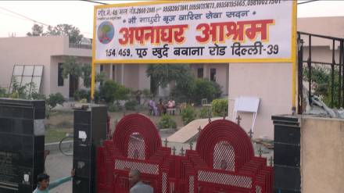
The ‘Apna Ghar’ Ashram Delhi was started on dated 28 October 2012 and the residential capacity of the Ashram was 70 at the time of Inauguration. During this financial year the construction of Ist floor of the building has been completed and due to this the residential capacity of this Ashram extended from 70 to 150. Store, Sanitary block and medical section has also been developed in this Ashram. All necessary requirements like beds, mattress, pillow, bed sheet, wearing cloths and required other furniture and fixtures has been fulfilled. Due to the increase of Inmates a Chapatti Machine having capacity 1000 chapatti per hour and a washing machine having capacity 50 kg cloths and dryer having capacity 30 kg also been arranged. Construction of IInd floor Building is under progress
APNA GHAR DELHI
Also an offer of started IInd unit of Delhi Ashram at Alipur 15 km away from present Ashram has received from Sh Naresh Jain a Social worker and well known businessman which will be started in the Ist quarter of the year 2014-15.The total covered area of this Building is 22000 sq feet and having residential capacity for 250 Inmates.

EXPENSION OF APNA GHAR ASHRAM-
This is a new approach particularly in mobilizing of network and alliance for helping helpless, homeless and resource less sick persons. Surprisingly these groups are found everywhere but options for serving them are very limited. In crisis of supporting hands and resources many helpless persons lost their lives and striving for resources. It is not feasible to provide services to every inmate from Bharatpur ‘Apna Ghar’ Ashram. To provide services to every inmates as per vision of the organization the Expansion plan was introduce by the Organisation .During this year following development was takes place regarding expension plan
Under Expansion Plan the `Apna Ghar` Ashram was started in Ajmer and Kota during the financial year 2011-12. During this Year ‘Apna Ghar’ Ashrams started at Bikaner, Kokilavan and Jodhpur.

Apna Ghar Ashram Bikaner:-
‘Apna Ghar’ Bikaner was established on dated 26 May 2012. The residential capacity of this Ashram is of 125 Inmates. All required necessity like bedding, cloths, furniture, medical equipments and kitchen ware, electric, water and sanitary system, commercial washing system and chapatti making machine, Tata magic helpline van etc. have been fulfilled in the Ashram with the public support. Recruitment of staff has also been made as per the necessity of inmates and the Ashram. The founders of this Ashram were Sh Hanuman Jhanvar, Sh Jugal Rathi, Sh Brijratan Tapdia, Sh Sukhdeo Chayal, Sh Ashok Mundhra. The Buildings was provided by the founder members to this Asram without any charge. The Inauguration ceremony was presided by Sh B.D. Kalla, President State Finance Commission Rajasthan. Sh Arjun Lal Meghwal, MP Bikaner was the Chief Guest of the ceremony. At present the services are provided for 113 Inmates in this Ashram. This Ashram is also running fully with the public support.
APNA GHAR BIKANER

Apna Ghar, Rameshwardas Ashram Kokilavan:-
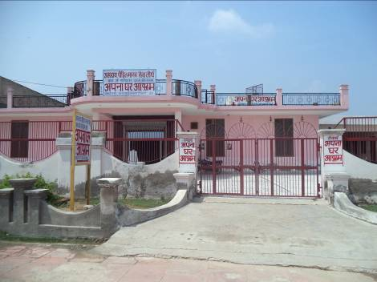
This Ashram was started on dated 8 September 2013 in Sani Dev Mandir Campus, Kokilavan Dham, Koshi, District-Mathura (UP). The Building for this Ashram was provided by Mahamandaleshawer Sh 1008 Sh Premdas Ji Majaraj, Chairman Sani Dev Mandir Trust, kokilavan Dham. The Residential capacity of this building is of 40 beds and Inmates admitted in it are 19 as on 31 March 2014. All required necessity has been fulfilled by the Organisation as per need of Inmates.
APNA GHAR KOKILAVAN

Apna Ghar Ashram Jodhpur:-

This Ashram was started on 2 March 2014 in
Astha Bhavan near Sastri Nagar Police Station, Pal
Road Jodhpur. The Building having capacity of 70 beds with facilities was provided by Sh Ganpat Ji Sand. The Inauguration ceremony was attended by Sant Sh Chandraprabhu Ji and Sh Lalitprabhu Ji Maharaj, Sushree Alka Shree, Ma Shantishawer Ji, including members of Bharatpur, Bikaner, Delhi Ashrams of the Organisation. As on 31 March 2014 the total number of 45 inmates were provided services in the Ashram. This Ashram is also running fully with the public support.
APNA GHAR JODHPUR

MEDICAL FACILITY-

To fulfill the medical requirements of patients of Apna Ghar Ashrams 9 part time Doctors, 6 Compounder and 10 health worker engaged in the services during the year. The patient also provide medical treatment in Government Hospital , Medical College and private hospitals as per requirements. There are 10 Ambulance in the Ashrams for providing immediate medical services and support to the Inmates of Ashrams.

MEDICAL HELPLINE AND MOBILITY-

Often seen that orphan and helpless patients injured in road accidents are die due to lack of medical support and care. Since the accident occurs in unpredicted manner, no attendants are available to look after these patients/injured persons in hospital, immediately. To fulfill this gap and support interruption, medical helpline support was initiated by the Organisation. It provides attendants in hospitals until some one from inmates families are not reported or take this responsibility. Every month the organization benefiting more than 150 patients through this helpline.

REHABILITATION-

It is an important intervention of Apna Ghar’s rehabilitation measures. After recovery of inmates from mental and physical sickness as per services and treatment provided by the Organisation the efforts made to search their home and send them back in their families. Apart from these inmates there are certain numbers of inmates whom family do not want to accept them back. These inmates being rehabilitated by involving them in the services of the Organisation. The steps involved in entire rehabilitation process include:

(i) Information to family members through letters and telephones.

(ii) Information to local police station and requested them to do needful steps.

(iii) In case of unidentified address or non-cooperation situation, local police are consulted to locate the exact addresses.

(iv) In case of non-cooperation by family legal action are supposed to be taken.

If all above efforts are failed, the members/representatives from organization visit to the concerning area along with person and ensure all possibilities of proper rehabilitation.
1620 inmates are admitted in this year. Total rehabilitated number is 724 in the year. Due to poor health, incurable diseases and old age 297 persons are expired. Including number of inmates carried in last year the strength of inmates in Apna ghar as on 31st March 2014 is 1438.

The categorization of these 1438 inmates is as under:-

CATEGORIES OF INMATES-

SR.NO. | CATEGORY | BHARATPUR | AJMER | KOTA | ALWAR | DELHI | BIKANER | KOKILAWAN | JODHPUR | TOTAL
1 | MENTALLY SICK | 501 | 21 | 51 | 8 | 74 | 61 | 10 | 26 | 752
2 | MENTALLY RETARDED | 126 | 26 | 0 | 9 | 5 | 11 | 1 | 8 | 186
3 | BLIND | 10 | 2 | 0 | 0 | 2 | 2 | 0 | 1 | 17
4 | PARALYSIS AND POLIO | 36 | 1 | 0 | 1 | 3 | 7 | 1 | 1 | 50
5 | HANDICAPPED | 14 | 0 | 0 | 2 | 4 | 8 | 0 | 0 | 28
6 | DEAF & DUMB | 25 | 1 | 0 | 2 | 2 | 3 | 0 | 3 | 36
7 | INJRED | 54 | 4 | 0 | 0 | 12 | 6 | 0 | 1 | 77
8 | FRACTURED | 25 | 2 | 0 | 0 | 4 | 5 | 1 | 1 | 38
9 | T.B. & ASTHAMA | 15 | 1 | 0 | 1 | 0 | 2 | 0 | 1 | 20
10 | EPILEPTIC | 11 | 0 | 0 | 1 | 0 | 0 | 2 | 0 | 14
11 | H.I.V./AIDS | 11 | 0 | 0 | 0 | 0 | 0 | 0 | 0 | 11
12 | CANCER | 1 | 0 | 0 | 0 | 0 | 2 | 0 | 0 | 3
13 | LEPROSY | 3 | 0 | 0 | 0 | 0 | 0 | 0 | 0 | 3
14 | HEALTHY KIDS | 55 | 0 | 0 | 0 | 0 | 0 | 0 | 0 | 55
15 | OTHER DISEASE | 77 | 4 | 0 | 0 | 17 | 4 | 0 | 0 | 102
16 | HEALTHY INMATES | 31 | 2 | 0 | 0 | 4 | 6 | 1 | 2 | 46
 | TOTAL MALE | 350 | 31 | - | 24 | 127 | 110 | 16 | 37 | 314
 | TOTAL FEMALE | 645 | 33 | 51 | 0 | 0 | 7 | 0 | 7 | 743
 | GRAND TOTAL | 995 | 64 | 51 | 24 | 127 | 117 | 16 | 44 | 1438

EXPANSION OF ASHRAM &APNAGHAR SEVA SAMITIES AND HELPLINES-

Organization has limited man power and resources to serve large number of helpless, homeless and resource less sick persons. Within this limited resources reaching to every patient is almost impossible for organization alone. For reaching at large number of such person, organization has promoted Apna Ghar seva samities (local units) and helpline at District and Tehsil level Town. 28 Apna Ghar seva samities and 48 help lines support the mission and objectives of organization in different part of state and the country at present. Delhi and Kota Ashram Samities and Apna Ghar Seva Samities in Ganganagar and Hanumadgharh was constituted during this year.

TURNING TOWARDS HUMANITARIAN PILGRIM-

The genesis of concept to serve helpless, orphan was inspired spirits and for fulfilling it very limited activities were initiated. This pretty small initiation of service through Apna Ghar magnificently is turning towards humanitarian hubs. Many of individuals after visiting Apna Ghar and staying couple of days they inspiring with its way of serving and humanity. Large number of people from villages and cities coming to visit Apna Ghar as pilgrims. Now the people visiting these places expressed as mental peace and stress therapy.

NATIONAL WIDE VOLUNTEERISM-

In modern age where high majority of population is fascinating to materialistic attributes the increasing numbers of volunteerism for caring humanity and helpless is consisting a big turning of re-synthesis of humanism. And making this in reality Apna Ghar through action based strategy is fortunate enough as numbers of supporters and volunteers have joined. More than 35000 persons have visited and involved themselves in serving the inmates as per their skills and talents. These visitors are providing shelters and food facilities by the organization.

BIRTH DAY CELEBRATION-

Since the inmates are mentally harassed they need attention in caring. Organization in order to give them homely environment to children and inmates the celebration of birth day is really giving them a joy and sense of special member in the family of Apna Ghar. In this celebration process all the inmates along with staffs take part in this moment. All together they wish for happy and prosper life to children. Birth celebration inculcates family spirit and enabling environment that they ever had got it.

WATER HUT-

Usually as previous year, organization has accessed 5 drinking water huts were set up in public places in the district. Similar to previous year it has been run for 5 months in stream summer season. Promising to fulfill the commitment Municipal Council of Bharatpur and individuals are associated in water hut services and trends have been maintained.

Details of Board Members as on 31/03/2014
Name | Position on Board | No. of meetings attended | Remuneration and reimbursements in Rs.
Mrs. Madhuri Bhardwaj | Patron | 2/2 | --
Mr. Veerpal Singh | President | 2/2 | --
Mr. N.P. Singh | Vice President | 2/2 | --
Mr. Rampal Bagri | Secretary | 2/2 | --
Mr. Ashok Mundhra | Finance Secretary | 2/2 | --
Mr. Asok Bansal | Advisor | 2/2 | --
Mr. Hanuman Jhanvar | Advisor | 2/2 | --
Mr. K.P. Sharma | Member | 2/2 | --
Dr. Ashok Khatri | Member | 2/2 | --
Distribution of staff according to salary levels as on 31/03/2014
Slab of gross salary (honararium) plus benefits (Rs per month) | Male (Nos) | Female (Nos) |  | Total (Nos)
<5000 | 49 | 46 |  | 95
5,000 - 10,000 | 75 | 22 |  | 97
10,000 - 25,000 | 2 | 1 |  | 3
25,000 - 50,000
50,000 - 1,00,000
1,00,000 >
Total | 126 | 69 |  | 195
Total cost of international travel by all personnel (including volunteers) and Board members
Name | Designation | Destination |  | Purpose
NIL | NIL | NIL |  | NIL
Total
 | Name | Designation |  | Remuneration (in Rs.)
Operational Head of the organisation: (including honorarium): | Dr. B.M. Bhardwaj | Founder & CEO |  | Volunteer
Highest paid person in the organisation (staff or consultant): | Miss. Seema Arora | Accountant |  | 13000
Lowest paid person in the organisation (staff or consultant): | 1- Smt. Kashmati  2- Smt. Dropa  3- Smt. Sheela Amma  4- Shri. Bajaranglal | Care Taker (Aaya)  Care Taker (Aaya)  Care Taker (Aaya)  Gate Man |  | 3500

LIST OF VOLUNTEERS

APNA GHAR BHARATPUR
1 | DR. MAHESH VIDHYARTHI | 8 | MISS BABITA GULATI
2 | DR. B.M. BHARDWAJ | 9 | MR. KRISHNA BANSAL
3 | DR. MADHURI BHARDWAJ | 10 | SHRI GHANSHYAMDAS
4 | DR. G.L AGRAWAL | 11 | SHRI KISHAN HATHRASI
5 | DR. PRADEEP DAGUR | 12 | SHRI SANDEEP KUMAR
6 | VEDHYA CHANDPRAKESH DIKSHIT | 13 | SHRI MOTILAL YADAV
7 | DR. SULEMAN KHAN

APNA GHAR DELHI
1 | SHRI RAMPAL BAGRI | 4 | SHRI KRISHAN KUMAR
2 | SHRI P. KUMAR | 5 | SHRI VIRENDRA KUMAR
3 | SHRI SHYAM TAPARIYA

APNA GHAR BIKANER
1 | DR. H.S. GANDHI | 3 | DR. ASHOK SINGHAL
2 | DR. HARFUL SINGH | 4 | DR. ANANT RATHI

LIST OF EMPLOYEES
APNA GHAR BHARATPUR
SR. NO. | NAME OF EMPLOYEE | DESIGNATION
1 | MISS UMESH SOLANKI | MANAGER
2 | MISS MONIKA | CHIEF SUPERVISER
3 | SHRI YAJUVENDAR BHARDWAJ | CASHIER
4 | SHRI GOVIND SINGH | UDC
5 | SHRI MOHAR SINGH | LDC (BAJHERA)
6 | SHRI KUNWAR SAIN | LDC (BANSI)
7 | SHRI SHAILESH CHOUDHARY | COMPUTER OPERATOR
8 | SHRI GOVIND SHAKYAWAR | COMPUTER OPERATOR
9 | SHRI PREM PRAKASH SINGH | COMPUTER OPERATOR
10 | SHRI JITENDRA BAJHERA | MPW
11 | SHRI LOKENDRA CHAHAR | M.P.W.
12 | SHRI GAYA PRASAD RAJPUT | SUPERVISOR (BANSI)
13 | SMT. RAMVATI | SUPERVISOR (FEMALE)
14 | SHRI AKASH KUMAR | OFFICE STAFF
15 | SHRI HARISH KUMAR | OFFICE STAFF
16 | SHRI ANIL KUMAR | STORE KEEPER
17 | SHRI MAHIPAL SINGH | TEACHER
18 | SHRI RANDHIR SINGH | ELECTRICIAN
19 | SHRI RAMESH SAIN | BARBER
20 | SHRI HARVEER SINGH | DRIVER
21 | SHRI SHIV RAM | TAILOR
22 | SMT. HARDEI AMMA | CARE TAKER
23 | SMT. DROPA | CARE TAKER
24 | SMT. KESHMATI | CARE TAKER
25 | SMT. SHEELA-II AMMA | CARE TAKER
26 | SMT. BANTA DEVI | CARE TAKER
27 | SMT. JAVITREE DEVI | CARE TAKER
28 | SMT. LAJJA DEVI | CARE TAKER
29 | SMT. NISHA KHAN | CARE TAKER
30 | SMT. NISHA-II | CARE TAKER
31 | SMT. RAMA DEVI | CARE TAKER
32 | SMT. SHANTI DEVI | CARE TAKER
33 | SMT. SHEELA / GORDHAN | CARE TAKER
34 | SMT. SHEELA-II / MAVASI | CARE TAKER
35 | SMT. SON DEVI | CARE TAKER
36 | SMT. USHA | CARE TAKER
37 | SMT. VIMALA | CARE TAKER
38 | SMT. MAMTA | CARE TAKER
39 | SHRI BABALU | CARE TAKER
40 | SHRI BANAR SINGH | CARE TAKER
41 | SHRI BHEEMSEN | CARE TAKER
42 | SHRI BIJENDRA | CARE TAKER
43 | SHRI CHIMMAN SINGH | CARE TAKER
44 | SHRI RAJENDRA SINGH | CARE TAKER
45 | SHRI RAMESH CHAND IKRAN | CARE TAKER
46 | SHRI RITESH | CARE TAKER
47 | SHRI SUNIL | CARE TAKER
48 | SHRI RAM SINGH | CARE TAKER
49 | SHRI PATIRAM | CARE TAKER
50 | SHRI SATISH | CARE TAKER
51 | SHRI AMIT | CARE TAKER
52 | SHRI ASHOK | CARE TAKER
53 | SHRI BHEM SINGH | CARE TAKER
54 | SHRI BANTI | CARE TAKER
55 | SMT. MACHHALA DEVI | CARE TAKER
56 | SHRI BHUPENDRA SHARMA | CARE TAKER
57 | SHRI MANOJ KUMAR | CARE TAKER
58 | SHRI DEVENDRA SHARMA | CARE TAKER
59 | SHRI SUSHIL | CARE TAKER
60 | SMT. PHOOL WATI | CLEANER
61 | SMT. PUSHPA | CLEANER
62 | SMT. SHEELA | CLEANER
63 | SMT. OMVATI/CHIMMAN | CLEANER
64 | SMT. MEENU | CLEANER
65 | SHRI JUGNU | CLEANER
66 | SHRI RAHUL | CLEANER
67 | SHRI RAJENDRA | CLEANER
68 | SHRI MONU | CLEANER
69 | SHRI RAKESH | CLEANER
70 | SHRI MOTI RAM | CLEANER
71 | SHRI RAMBHO | CLEANER
72 | SHRI NAHAR SINGH | CLEANER
73 | SHRI PREM PAL | COW MAN
74 | SMT. KAMLESH | COW WOMAN
75 | SMT. BASANTI/HARDEI | DISH WASHER WOMEN
76 | SHRI RAM BAI | DISH WASHER WOMEN
77 | SHRI LAXMIKANT | DRIVER
78 | SHRI ROOP SINGH | DRIVER
79 | SHRI OMVEER | DRIVER
80 | SHRI VEDPRAKASH | DRIVER
81 | SHRI KEDAR SINGH | HELPLINE
82 | SHRI ASHOK KUMAR | HELPLINE
83 | SMT. KAMLESH-II | KITCHEN STAFF
84 | SMT. LAJJA DEVI - II | KITCHEN STAFF
85 | SMT. LONGSHREE | KITCHEN STAFF
86 | SMT. MEENA MALONI | KITCHEN STAFF
87 | SMT. SHEELA DEVI-II / SURESH | KITCHEN STAFF
88 | SMT. OMVATI | KITCHEN STAFF
89 | SMT. SHEELA DEVI-I / VIJAY | KITCHEN STAFF
90 | SMT. PRIYANKA SHARMA | MEDICAL STAFF
91 | SMT. SUSHILA | MEDICAL STAFF
92 | KU. SAMAN | MEDICAL STAFF
93 | SHRI KAILASHI | MEDICAL STAFF
94 | SHRI BANTU | MEDICAL STAFF
95 | SHRI HORILAL BAJHERA | MEDICAL STAFF
96 | SHRI DHARAM VEER | MEDICAL STAFF
97 | SHRI RAJEEV | MEDICAL STAFF
98 | SHRI RAMESH | MEDICAL STAFF
99 | SHRI GOPIRAM | WASHER MAN
100 | SHRI SIKANDER | WASHER MAN
101 | SMT. KOKA DEVI | WASHER WOMAN

APNA GHAR AJMER
SR. NO. | NAME OF EMPLOYEE | DESIGNATION
1 | SHRI YOGENDRA MATHUR | OFFICE INCHARGE
2 | SHRI MAHESH RAJPOOT | DRIVER
3 | SHRI BHAWANI SINGH | MEDICAL
4 | SMT. SUNITA SHARMA | MEDICAL
5 | SHRI RAVIKANT | COMPUTER OPERATOR
6 | SHRI SUBHASH | GATE KEEPAR
7 | SHRI DEVENDRA SINGH | GATE KEEPAR
8 | SHRI DESHRAJ | CARE TAKER
9 | SHRI RAHUL | CARE TAKER
10 | SHRI RANDHIR | CARE TAKER
11 | SHRI KALU | CLEANER
12 | SMT. GUDDI | CLEANER
13 | SMT. MEERA DEVI | CARE TAKER
14 | SMT. SITA DEVI | CARE TAKER
15 | SMT. AAKUDI PRAJAPAT | CARE TAKER
16 | SMT. SAVITRI | CARE TAKER
17 | SMT. AMRIT KANWAR | CARE TAKER
18 | SMT. ANAND | KITCHEN STAFF
19 | SMT. NOOTAN AJMERA | KITCHEN STAFF

APNA GHAR ALWAR
SR.  NO. | NAME OF EMPLOYEE | DESIGNATION
1 | SHRI JAGDISH PRASAD SAINI | OFFICE INCHARGE
2 | SHRI PARSHURAM SINGH | KITCHIN STAFF
3 | SHRI CHARAN SINGH | CARE TAKER
4 | SHRI RANVEER SINGH | CARE TAKER

APNA GHAR DELHI
 | NAME OF EMPLOYEE | DESIGNATION
1 | SHRI PAVAN KUMAR FAUJDAR | OFFICE INCHARGE
2 | SHRI VIJAY KUMAR | OFFICE ASSISTANT
3 | SHRI PAVAN KUMAR NUNERA | COMPUTER OPERATOR
4 | SHRI SIYARAM-I | MARKETING SUPERVISOR
5 | SHRI PINTU SINGH | MEDICAL STAFF
6 | SHRI SIYARAM-II | MEDICAL STAFF
7 | SHRI NANDKISHOR | SUPERVISOR
8 | SMT SUNITA | L.D.C
9 | SHRI KEDAR SINGH | M.P.W
10 | SHRI VIKRAM SINGH | STORE KEEPAR
11 | SHRI VEER SINGH | KITCHEN STAFF
12 | SMT DHAN DEVI | KITCHEN STAFF
13 | SHRI RAMESHWAR SINGH | KITCHEN STAFF
14 | SHRI RAJU (CHHOTU) | KITCHEN STAFF
15 | SHRI VINOD KUMAR | DRIVER
16 | SHRI GAJENDRA SINGH | DRIVER
17 | SHRI DHANESWAR | CARE TAKER
18 | SHRI HARIKESH SINGH | CARE TAKER
19 | SHRI GADDAR SINGH | CARE TAKER
20 | SHRI OMVEER SINGH | CARE TAKER
21 | SMT AJUBA DEVI | LADIES CARE TAKER
22 | SHRI CHHOTU | CLEANER
23 | SHRI AKASH | CLEANER
24 | SHRI TINKU | CLEANER

APNA GHAR KOTA
SR. NO. | NAME OF EMPLOYEE | DESIGNATION
1 | MISS. MONIKA SHARMA | OFFICE ASSISTANT
2 | SHRI. MAHAVEER SINGH | M.P.W.
3 | SHRI. RAKESH KUMAR MEENA | MEDICAL
4 | MISS. MEENA | MEDICAL
5 | MISS. VIMLESH | MEDICAL
6 | MISS. RUKMANI | KITCHEN STAFF
7 | MISS. SUMITRA | KITCHEN STAFF
8 | MISS. RENU NEVAR | CARE TAKER
9 | MISS. PARVATI BAI | CARE TAKER
10 | MISS. CHAMELI BAI | CARE TAKER
11 | MISS. SHYAMA BAI | CARE TAKER
12 | MISS. MANJU SHARMA | CARE TAKER
13 | MISS. MOHNI BAI | CARE TAKER
14 | MISS. JAGANNATHI BAI | CARE TAKER
15 | SHRI. BABULAL PRJAPAT | GATE KEEPAR
16 | MISS. SUMALATA SAINI | CLEANER

APNA GHAR BIKANER
SR. NO. | NAME OF EMPLOYEE | DESIGNATION
1 | SHRI RAMESH RATHI | OFFICE IN CHARGE
2 | SHRI RISHI KUMAR | OFFICE STAFF
3 | MISS SEEMA ARORA | ACCOUNTANT
4 | SHRI OM SUDHAR | ACCOUNTANT
5 | SHRI GIRIRAJ BARADH | OFFICE STAFF
6 | SHRI RADHESHYAM | TAILOR
7 | SHRI RAJU SHARMA | MEDICAL
8 | SHRI GYAN SINGH | CARE TAKER
9 | SHRI KISHAN SINGH | CARE TAKER
10 | SHRI OMPRAKASH | CARE TAKER
11 | SHRI GOKUL SINGH | CARE TAKER
12 | SHRI SONU | CARE TAKER
13 | SHRI OMVEER | CARE TAKER
14 | SMT. ANARDEI | CARE TAKER
15 | SHRI RANVEER SINGH | CARE TAKER
16 | SHRI MEGHRAJ BHOJAK | SUPERVISOR
17 | SHRI AMARCHAND | KITCHEN STAFF
18 | SHRI CHANDAN | KITCHEN STAFF
19 | SMT. MAYA DEVI | KITCHEN STAFF
20 | SMT. LAXMI DEVI | KITCHEN STAFF
21 | SHRI RINKU | CLEANER
22 | SHRI MOHANLAL | CLEANER
23 | SHRI RAJESH | CLEANER
24 | SHRI BABULAL | CLEANER
25 | SHRI SHRIKISHAN | WASHERMAN
26 | SHRI BAJRANG LAL | GATE KEEPAR

APNA GHAR KOKILAWAN
1 | SHRI JAI SINGH | OFFICE IN CHARGE
2 | SHRI YOGESH | CARE TAKER
3 | SHRI SHYAM SUNDAR | CARE TAKER
4 | SHRI RAHUL | CLEANER
5 | SHRI TARA CHAND | KITCHEN STAFF

Staff Details:
Gender | Paid (Part Time) | Paid (Full Time) | Volunteer
Male |  | 126 | 21
Female |  | 69 | 1

AVERAGE HONARARIUM = APPROX `52,200 / YEAR
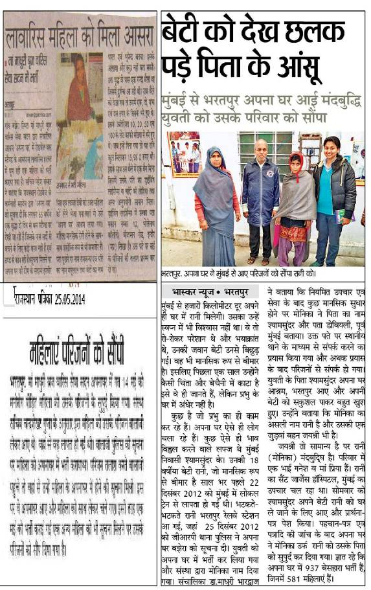
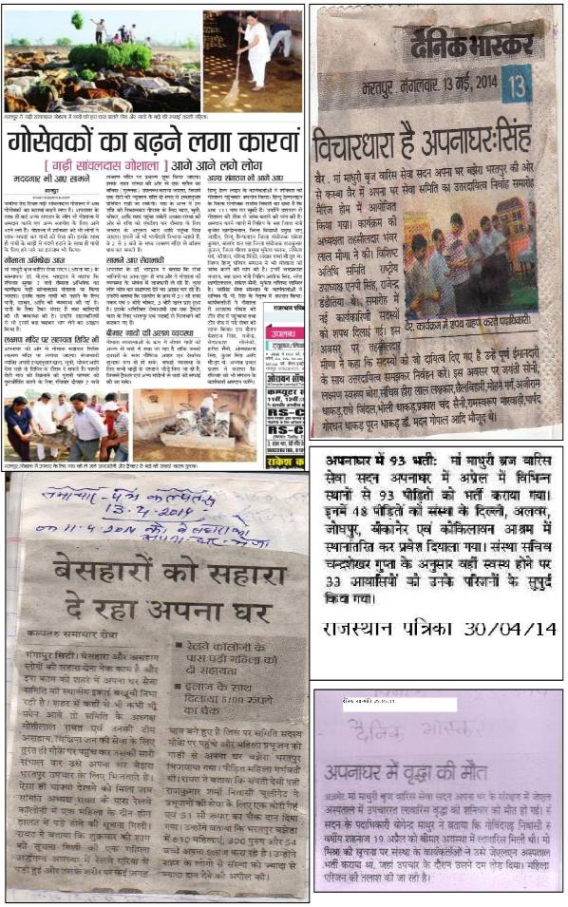
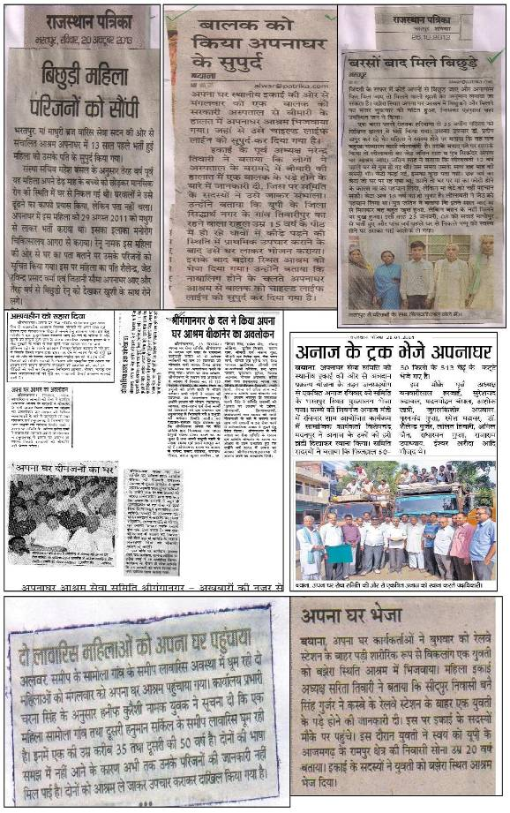

PHOTO GALLERY (SERVICE PART)

CASE-1
DURING ADMISSION- JYOTI IN CRITICAL CONDITION
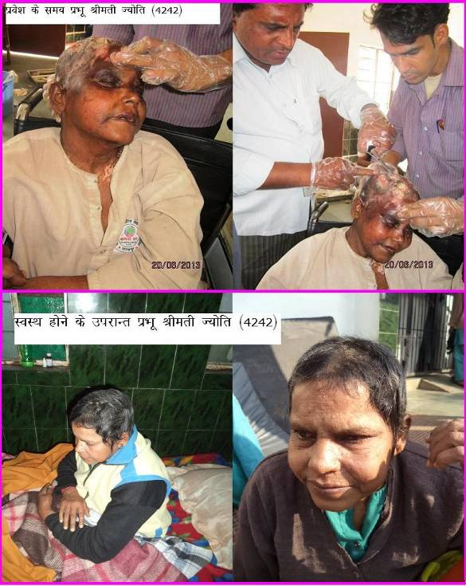
JYOTI AFTER RECOVERY IN APNG GHAR ASHRAM
CASE-2
DURING ADMISSION- SUMAN IN CRITICAL CONDITION, 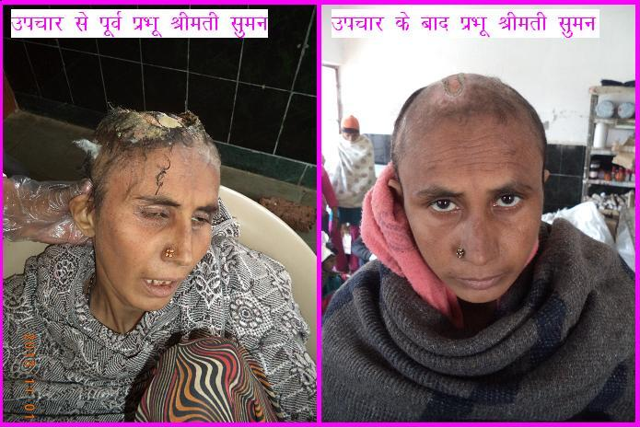
TREATMENT PROVIDES BY THE ORGANISATION AND SHE IS COMPLETELY RECOVERED FROM WOUNDS. AT PRESENT SHE LIVES IN APNA GHAR ASHRAM.
CASE-3
BHAGWANDEI BEFOR ADMISSION
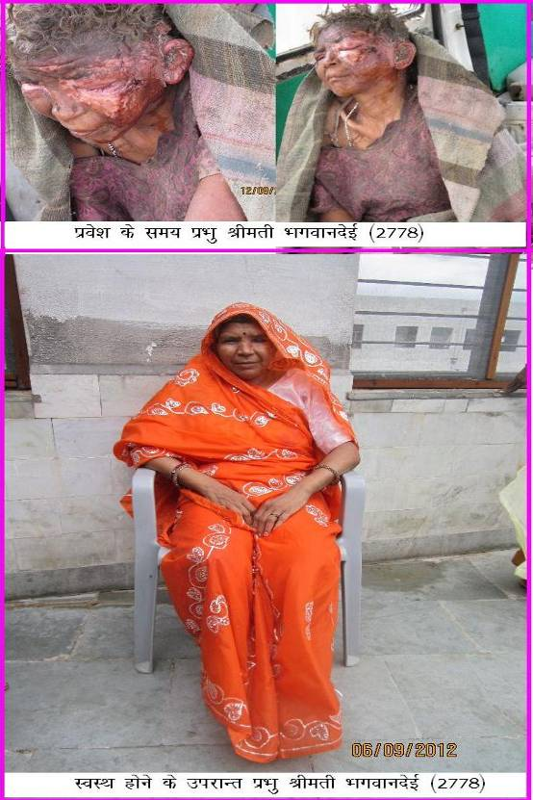
BHAGWANDEI IN APNA GHAR ASHRAM AFTER RECOVERY
CASE-4

BEFORE ADMISSION IN SICK CONDITION.

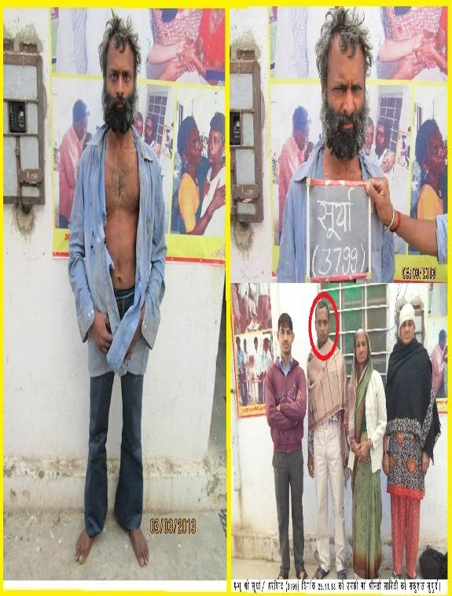
AFTER RECOVERY- WITH HIS RELATIVES DURING HAND OVER.

CASE-5

DURING ADMISSION- SATISH IN DISTURBED CONDITION

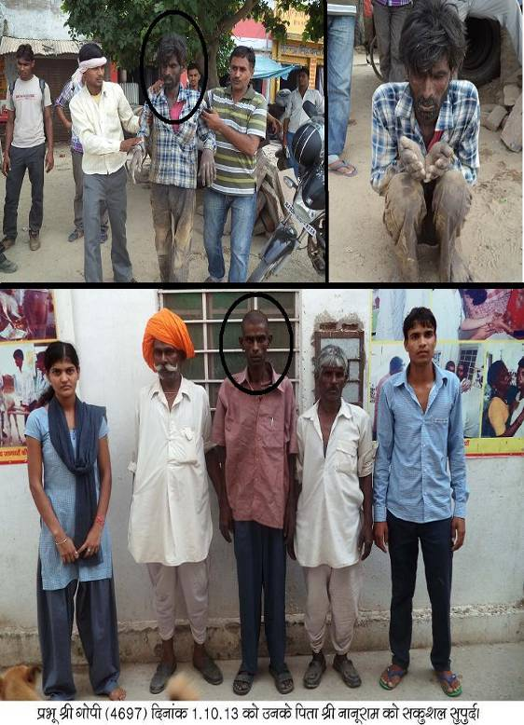
AFTER RECOVERY- READY TO GOING THERE HOME

PART B - AUDIT REPORT

AUDIT REPORT FOR THE YEAR 2013-14

MAA MADHURI BRIJ VARIS SEWA SADAN SANSTHA APNA GHAR, BAJHERA BHARATPUR
BALANCE SHEET
AS ON 31ST MARCH, 2014
LIABILITIES | AMOUNT | ASSETS | AMOUNT
CAPITAL FUND |  | FIXED ASSETS
AS PER LAST YEAR 47416118.35 |  | BUILDING CONSTRUCTION | 83999234.00
ADD: DURING THE YEAR 19736996.20 | 67153114.55 | BUILDING | 405659.00
 |  | LAND | 15815802.00
EXCESS OF INCOME OVER EXPENDITURE |  | MACHINERY & EQUIPMENT | 1510250.00
AS PER LAST YEAR 34174857.02 |  | MOBILE | 14285.00
ADD: DURING THE YEAR 19705332.75 | 53880189.77 | CYCLE | 3220.00
 |  | BOOKS | 11180.00
UNSECURED LOANS |  | CAMERA | 11700.00
BANWARILAL HARJAHI | 49000.00 | COMPUTER | 371012.00
BHUDEV SHARMA | 50000.00 | ELECTRICAL INSTRUMENTS &EQUIPMENTS | 3651602.00
BRIJRAJ SHARMA | 50000.00 | ENGINE(DIESEL) | 32000.00
DEVENDER KUMAR GUPTA | 100000.00 | FURNITURE & FITTINGS | 2476567.00
GIRDHARI AGARWAL | 100000.00 | GAUSALA | 556870.00
JAGDISH PRASAD SHARMA | 50000.00 | GENERATOR | 510000.00
JITENDAR AGARWAL JI | 250000.00 | INVERTOR | 86000.00
PRABHA GUPTA | 100000.00 | MURATI | 8000.00
SHREE UMESH SHARMA JI | 50000.00 | PLANT & MACHINERY | 1085825.00
SHYAMBIHARI JI | 50000.00 | PROTECTION CYLENDER | 12500.00
SMT KUSUM AGARWAL | 100000.00 | VEHICLE | 5626183.00
HALALU CLIM FOOTWEAR | 1000000.00 | SAFETY SERVICE | 9804.00
JINDAL APPARELS | 500000.00 | SOLAR WATER HEATING SYSTEM | 64400.00
SHANKAR SOMANI | 1000000.00 | PRINTER | 12500.00
CURRENT LIABILITIES |  | INVESTMENT
 |  | FDR | 1955289.03
SUNDRY CREDITORS
AWASHI ADMIT DEPOSIT | 190446.00 | CURRENT ASSETS
LOAN | 200000.00
MITTAL GLASSES | 21000.00 | DEBTORS
NN STORE INDUSTRIES | 4946.00 | RAJASTHAN MEDICAL SERVICES CORPORATION | 11882.84
SAINI SURGICAL COMPANY | 6422.00
SUNDRY PAYABLES |  | DEPOSITS
BILLS PAYABLE | 283858.00 | ELECTRICITY SECURITY | 12850.00
PROVISION FOR ELECTRICITY | 19860.00 | TELEPHONE SECURITY | 500.00
SALARY PPAYABLE | 76793.00 | KOKELAVAN ASHARAM | 229000.00
 |  | AWASI WITHDRAWL
 |  | MINISTRY OF SOCIAL JUSTICE & EMPOWERMENT | 1769548.80
 |  | T.D.S | 14222.00
 |  | CASH IN HAND | 1202046.50
 |  | BANK ACCOUNTS
 |  | With PNB Bansi | 85311.30
 |  | With PNB DELHI | 211783.30
 |  | With PNB Ajmer | 69491.30
 |  | With PNB Ajmer SWEEP A/C | 440000.00
 |  | With PNB ALWAR | 194940.30
 |  | With PNB Kota | 37409.78
 |  | With PNB Kota SWEEP A/C | 1570000.00
 |  | With PNB Bikaner | 98524.15
 |  | With SBBJ | 9470.72
 |  | with SBI | 178916.42
 |  | with Canara bank FCRA | 26456.30
 |  | With RGB | 1273.00
 |  | With PNB Bachamadi | 746505.58
 |  | With CHIRAYU | 2015.00
 |  | With kalyan kosh | 45000.00
 |  | With Sewa sathi 256538 | 63000.00
 |  | CHEQUE PENDING | 35600.00
 | 125285629.32 |  | 125285629.32
AUDITOR'S REPORT
IN TERMS OF OUR REPORT OF EVEN DATE ANNEXED
 |  |  | FOR N. C. GOYAL & CO.
DATE: 29.09.2014 |  |  | Chartered Accountants
PLACE : BHARATPUR
 |  |  | (CA.Naresh Goyal)
 |  |  | Prop.
 |  |  | MRN : 095270
 |  |  | FRN: 15406N

MAA MADHURI BRIJ VARIS SEWA SADAN APNA GHAR SANSTHA, BAJHERA
INCOME & EXPENDITURE ACCOUNT
FOR THE YEAR ENDED ON 31ST, MARCH, 2014
EXPENDITURE |  | AMOUNT | INCOME |  | AMOUNT
Old Age, Orphans, Sever-illness & Mentally |  | 29575715.41 | Donation For Recurring Exps. |  | 47582622.12
disorder person welfare home exps. |  |  | Membership Fees |  | 2941899.00
General Expenses |  | 5066246.64 | Donation Received In Kind |  | 3094094.25
Excess of income over expenditure |  | 19705332.75 | Bank Interest |  | 633946.43
 |  |  | Other Income |  | 94733.00
 |  | 54347294.80 |  |  | 54347294.80
PRESIDENT |  |  | SECRETARY
AUDITOR'S REPORT
IN TERMS OF OUR REPORT OF EVEN DATE ANNEXED
 |  |  |  |  | FOR N. C. GOYAL & CO.
DATE: 29.09.2014 |  |  |  |  | Chartered Accountants
PLACE : BHARATPUR
 |  |  |  |  | (CA.Naresh Goyal)
 |  |  |  |  | Prop.
 |  |  |  |  | MRN : 095270
 |  |  |  |  | FRN: 15406N

MAA MADHURI BRIJ VARIS SEWA SADAN APNA GHAR SANSTHA, BAJHERA, BHARATPUR
RECEIPTS & PAYMENT ACCOUNT
FOR THE YEAR ENDED ON 31ST, MARCH, 2014
RECEIPTS |  | AMOUNT | PAYMENTS |  | AMOUNT
Balance b/d |  |  | Furniture & Fixtures |  | 888807.00
Cash in hand |  | 979245.54 | Building Construction |  | 34522892.00
cash at bank:- |  |  | Electronoc Item & INSTRUMENTS |  | 1335756.00
With PNB ALWAR |  | 245805.50 | Printer Purchased |  | 12500.00
With PNB DELHI |  | 1517097.00 | UPS & invertor purchase (battery) |  | 28000.00
With PNB Bansi Prakalap |  | 967418.00 | Generator |  | 290000.00
With PNB Ajmer |  | 698939.00 | Camera |  | 5600.00
With PNB Kota |  | 30318.48 | VEHICLE |  | 979841.00
With RGB |  | 26655.00 | Electricity security |  | 12850.00
With SBBJ |  | 40546.90 | Telephone security |  | 500.00
with SBI |  | 725803.42 | Machinery & tools |  | 1911226.00
with Canara bank FCRA |  | 101896.45 | MOBILE |  | 3630.00
With Chirayu |  | 2015.00 | Diesel (Eigine) |  | 50.00
With PNB Bachamadi |  | 228405.50 | Murati |  | 8000.00
With canara bank |  | 36118.03 | Gausala |  | 124500.00
With kalyan kosh |  | 45000.00 | Computer |  | 270162.00
 |  |  | FDR |  | 797660.00
Membership Fee |  | 2941899.00 | Old Age, Orphans, Sever-illness & Mentally
Donations :- |  |  | disorder person welfare home expenses:-
For Recurring Exps. |  | 48036552.84 | Honarium & Allowances |  | 7198096.00
 |  |  | CRIMINATION EXPENSES |  | 145143.00
For Non Recurring Exps. |  | 16966002.20 | Day celebration EXPENSES |  | 110610.00
RECIEVED FROM PARTIES |  |  | Medicine Exps. |  | 2680855.16
Decrease in receivables |  | 16698.00 | FOOD EXPENSES |  | 9337555.50
RECEIVED FROM UNSECURED LOANS |  | 949000.00 | HOLIYATI ACCOUNT |  | 14600.00
HALALU CLIM FOOTWEAR |  | 1000000.00 | Clothing & Others Exps. |  | 1404887.00
JINDAL APPARELS |  | 500000.00 | functional vehical |  | 191571.00
SHANKAR SOMANI |  | 1000000.00 | Travelling & Conveyance Expenses |  | 932506.00
Ministry of social justice & empowerment (M.R PROJECT) |  | 2443901.00 | Vatika Development |  | 64569.00
Amount rec. Awashi admit deposit |  | 335802.00 | TDS on bank interet |  | 3884.00
 |  |  | care & cleaning |  | 63386.00
EXPENSES & INCOMES |  |  | welfare fund |  | 19400.00
 |  |  | General Expenses:
HOLIYATI ACCOUNT |  | 14542.00 | Telephone & Postage Exp. |  | 199911.00
SALARY & WAGES |  | 4100.00 | Printing & Statinery |  | 677549.00
Bank Interest |  | 623780.28 | vehical maintenses |  | 441335.00
Misc. Receipts |  | 24880.00 | Internet Expenses |  | 2000.00
 |  |  | Boaring Expenses |  | 67330.00
 |  |  | Insurance |  | 54491.00
 |  |  | GONIKETAN EXPENSES |  | 403641.00
 |  |  | CONVANCE |  | 310136.00
 |  |  | Newspaper expenses |  | 10866.00
 |  |  | Electricity & Water Charges |  | 1896114.00
 |  |  | Audit Fee |  | 20000.00
 |  |  | OFFICE EXPENSES |  | 564336.00
 |  |  | Repair & Maintenance |  | 1774796.00
 |  |  | MISCLANEOUS EXPENSES |  | 1598047.54
 |  |  | Legal expenses |  | 13794.00
 |  |  | Salary & wages expenses |  | 1149544.00
 |  |  | Bank Charges (commission) |  | 44123.95
 |  |  | Current assets
 |  |  | Devender (reti rohadi wala) |  | 65300.00
 |  |  | Ganesh steel |  | 141552.00
 |  |  | Shrishti sales corporation |  | 126000.00
 |  |  | Loans & advances |  | 189000.00
 |  |  | Pipe palace trading co. |  | 20224.00
 |  |  | Paid to creditors & bills payable |  | 1727149.50
 |  |  | PAID TO AMBESH GAS SERVICE |  | 880.00
 |  |  | Awashi admit return amount |  | 49185.00
 |  |  | Payment to creditors |  | 261227.84
 |  |  | AWASI WITHDRAWL |  | 88108.00
 |  |  | Kokelavan Asharam |  | 229000.00
 |  |  | Balance c/d
 |  |  | Cash in hand |  | 1202046.50
 |  |  | Cash at bank:-
 |  |  | With PNB Bansi |  | 85311.30
 |  |  | With PNB DELHI |  | 211783.30
 |  |  | With PNB Ajmer |  | 69491.30
 |  |  | With PNB Ajmer SWEEP A/C |  | 440000.00
 |  |  | With PNB ALWAR |  | 194940.30
 |  |  | With PNB Kota |  | 37409.78
 |  |  | With PNB Kota SWEEP A/C |  | 1570000.00
 |  |  | With PNB Bikaner |  | 98524.15
 |  |  | With SBBJ |  | 9470.72
 |  |  | with SBI |  | 178916.42
 |  |  | with Canara bank FCRA |  | 26456.30
 |  |  | With RGB |  | 1273.00
 |  |  | With PNB Bachamadi |  | 746505.58
 |  |  | With CHIRAYU |  | 2015.00
 |  |  | With kalyan kosh |  | 45000.00
 |  |  | With Sewa sathi 256538 |  | 63000.00
 |  |  | Cheque pending |  | 35600.00
 |  | 80502421.14 |  |  | 80502421.14
AUDITOR'S REPORT
IN TERMS OF OUR REPORT OF EVEN DATE ANNEXED
 |  |  |  |  | FOR N. C. GOYAL & CO.
DATE: 29.09.2014 |  |  |  |  | Chartered Accountants
PLACE : BHARATPUR
 |  |  |  |  | (CA.Naresh Goyal)
 |  |  |  |  | Prop.
 |  |  |  |  | MRN : 095270
 |  |  |  |  | FRN: 15406N

